**1. What are the benefits of using CSS?**

1. faster page speed.

2. Better User Experience.

3. Quicker Development Time.

4. Easy Formatting Changes.

5. Compatibility Across Devices.

**2. What are the disadvantages of CSS?**

There exists a scarcity of security.After making the changes we need to confirm the compatibility if they appear. The similar change affects on all the browsers. Browser compatibility (some styles sheet are supported and some are not).CSS works differently on different browsers. IE and Opera supports CSS as different logic.

**3. What is the difference between CSS2 and CSS3?**

CSS allows web designers to use animations, CSS3 ups the stakes with more complex animation properties such as transforms, transitions, and special effects.

**4. Name a few CSS style components**

Selector: class name, id name or element name that is target.

Attribute: name of the attribute you want to style for example border, color,background, position etc.

Value of Property: value that will be assigned to attribute.

**5. What do you understand by CSS opacity?**

The opacity CSS property sets the opacity of an element. Opacity is the degree to which content behind an element is hidden, and is the opposite of transparency.

**6. How can the background color of an element be changed?**

To add background color in HTML, use the CSS background-color property. Set it to the color name or code you want and place it inside a style attribute. Then add this style attribute to an HTML element, like a table, heading, div, or span tag.

**7. How can image repetition of the backup be controlled?**

This task can be achieved by using the background-repeat property that will help us to control the repetition of the image. The background-repeat property in CSS is used to repeat the background image both horizontally and vertically. It also decides whether the background image will be repeated or not.

**8. What is the use of the background-position property?**

The background-position property sets the starting position of a background image. Tip: By default, a background-image is placed at the top-left corner of an element, and repeated both vertically and horizontally.

**9. Which property controls the image scroll in the background?**

The background-attachment property sets whether a background image scrolls with the rest of the page, or is fixed.

**10. Why should background and color be used as separate properties?**

There are two reasons behind this: It enhances the legibility of style sheets. The background property is a complex property in CSS, and if it is combined with color, the complexity will further increase.

**11. How to center block elements using CSS1?**

To centrally align the block elements, we can simply make use of the <center> tag. All the elements within the <center> tag will be centrally aligned.

**12. How to maintain the CSS specifications?**

The CSS specifications are maintained by the World Wide Web Consortium (W3C). Even though every browser supports CSS, there are many inconsistencies in the supported specification version. Some browsers even have their own implementation of the specification and have proprietary (vendor) prefixes.

**13. What are the ways to integrate CSS as a web page?**

1. Inline - by using the style attribute inside HTML elements.

2. Internal - by using a <style> element in the <head> section.

3. External - by using a <link> element to link to an external CSS file.

**14. What is embedded style sheets?**

It allows you to define styles for a particular HTML document as a whole in one place. This is done by embedding the <style></style> tags containing the CSS properties in the head of your document.

**15. What are the external style sheets?**

An external style sheet is a separate CSS file that can be accessed by creating a link within the head section of the webpage. Multiple webpages can use the same link to access the stylesheet.

**16. What are the advantages and disadvantages of using external style sheets?**

Advantage:- To apply a rule to multiple pages, an external style sheet is used. An external style sheet is a separate CSS file that can be accessed by creating a link within the head section of the webpage. Multiple webpages can use the same link to access the stylesheet.

Disadvantage:- The execution of the file may be deferred till the external style sheet is loaded. While implementing style sheets, we need to test Web pages with multiple browsers in order to check compatibility issues.

**17. What is the meaning of the CSS selector?**

CSS selectors are used to "find" (or select) the HTML elements you want to style. We can divide CSS selectors into five categories: Simple selectors (select elements based on name, id, class) Combinator selectors (select elements based on a specific relationship between them).

**18. What are the media types allowed by CSS?**

1. max-width-576px.

2. min-width-576px.

3. min-width-786px.

4. min-width-992px.

**19. What is the rule set?**

A ruleset provides a unit of execution for rules and Decision Tables. In addition, rulesets provide a unit of sharing for rules; rules belong to a ruleset. Multiple rulesets can be executed in order. This is called rule flow.

**20. Create Layouts:-**

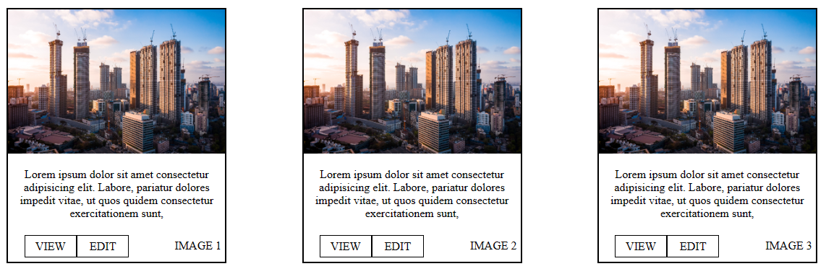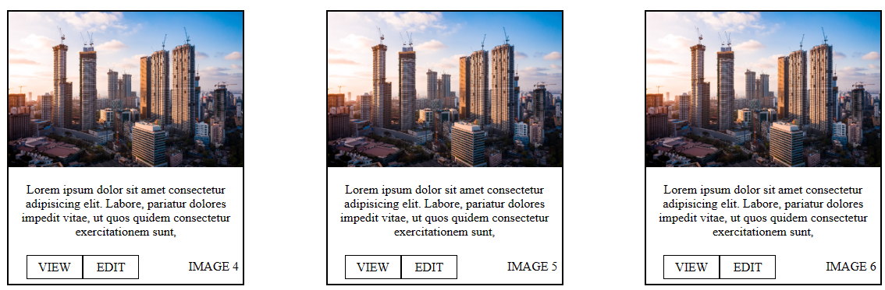

**HTML CODE :-** **https://github.com/kppadsala/software-eng/blob/main/css/assinment/assinment%20layout.html**

**CSS CODE :-** **https://github.com/kppadsala/software-eng/blob/main/css/assinment/style.css**